Figure 3.4 Yuri Norstein’s profoundly personal and dream-like film, Tales *of Tales,* uses the distinctiveness of the animated film to move fluidly between images drawn from the unconscious, vivid memories of childhood, and the perceived pictorial-ness of the natural world

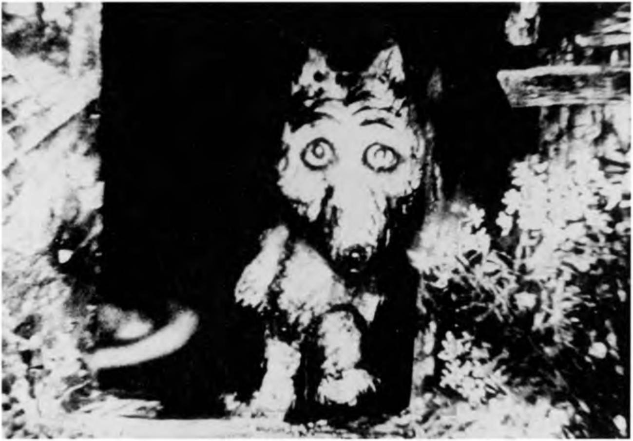

Norstein combines the familiarity of the language of live-action film (close-ups, lateral pans across space, dissolves, depth and perspective movement, ‘invisible’ editing etc.) with the language of animation (metamorphosis, condensation, synecdoche, symbol and metaphor etc.) to authenticate the images preserved by memory, defined by history, located only in the mind.9

Sound

The soundtrack of any film, whether animated or live-action, tends to condition an audience’s response to it. Sound principally creates the mood and atmosphere of a film, and also its pace and emphasis, but, most importantly, also creates a vocabulary by which the visual codes of the film are understood. ‘Sound’ in film may be composed of a number of elements:

1. Voiceover [omnipotent narrator] (non-diegetic)
2. Character monologue (diegetic)
3. Character monologue (non-diegetic)
4. Character dialogue (diegetic)
5. Character dialogue (non-diegetic)
6. Instrumental music (diegetic)
7. Instrumental music (non-diegetic)
8. Song [music with lyrics] (diegetic)
9. Song [music with lyrics] (non-diegetic)
10. Sound effects (diegetic)
11. Sound effects (non-diegetic)
12. Atmosphere tracks

There are a number of tensions that are generated at the narrative level between sound which is added to the visuals from without and the sound directly corre­ spondent to the events within the film itself. The early Fleischer Brothers’ shorts and the initial output of the Warner Brothers Studio are essentially early forms of the music video in the sense that the cartoon events often directly accompany, and take their narrative imperatives from, a song.10 This necessitates different modes of performance from animated characters and choices concerning whether the cartoon should literally interpret the words of a song, deviate from the song’s story, or partially integrate the content of the lyrics with other narrative concerns developed through the imagery alone. The use of music is entirely related to its appropriateness in the determination of mood or the timing of a sequence, but what is also important is the idea, noted by Philip Brophy, that music essentially operates as a ‘present tense’ in most animated vehicles (Cholodenko, 1991: 81). This sense of now-ness suggested by different kinds of music consistently informs the implicit emotional narrative of a piece. Music may be normally interpreted through the feelings it inspires, and is deployed to elicit specific emotional responses in the viewer and define the underlying *feeling bases* in the story. The music, and its role as a catalyst for the emotive dynamics of an animated film, fundamentally informs how an audience may interpret the film.

Voice remains an intrinsic aspect of most story-telling, and in animation, is used in a number of ways. From the use of ‘real’, un-scripted, non-performance voices through to the overt mimicry and caricature in the vocal characterisations by such revered figures as Mel Blanc and Dawes Butler, the tone, pitch, volume, and onomatopoeic accuracy of spoken delivery carries with it a particular guiding meta-narrative that supports the overall narrative of the animation itself. In the same way as music, the voice, in regard to how it sounds, as much as what it is saying, suggests a narrative agenda. This is particularly important in hyper-realist texts because the emotional synchrony of the voice is reinforcing modes of naturalism - a naturalism, exemplified by Disney, which in defining itself so precisely took on lyrical qualities. The soundtrack of the hyper-realist film prioritises diegetic naturalism but uses the non-diegetic mode to heighten the emotive aspects suggested by the vocal ‘performance’ of the characters and the implied nature of their context in sound terms. Disney’s pre-dominant output, and hyper-realist animated films, in general, seek to ally the tenor and implication of the voice (speaking or in song) with the atmosphere tracks that help to define their environment, but as Brophy points out, this is challenged in the post-war

period by the Warner Brothers Studio, who heightened the influence and effect of the sound effect:

If Disney is splashing liquid, Warner Bros, is crashing metal; if Disney mobilised the animatic apparatus, Warner Bros, revved it up to full throttle; and if Disney aspired to the organic life of music, Warner Bros, capitalised on the unnatural presence of sound effects.

(Brophy, 1991: 88)

Chuck Jones confirms this view in his praise of Warner Brothers sound effects editor, Treg Brown:

... he had a wonderful, surprising sense of humour in the editing of sound effects, and that was, whenever possible, never use a sound effect that you’d expect. It should have the same effect on your ears but should not be the same sound effect. And in one [. . .] of the Road Runner cartoons, where the Coyote tries to harpoon the Road Runner and the Coyote’s on the rope and he’s dragged across the desert, well, you’ll notice not one sound that is correct. There’s a broken bottle, there’s a spring, metal filings falling on a drum and all kinds of other sounds. So your eye sees one thing and your ear says just the opposite.

(Jones, 1991: 61)

Such, of course, was the extent and excess of the visual imagination in these cartoons, that actions and events were depicted which it was impossible to imagine actual sound for. What, for example, does a falling boulder or horse or sink actually sound like? Sounds had to be created to match certain events, and as such, became amusing through their incongruousness in relation to ‘real world’ sounds applied faithfully to their visual source. This inevitably affected the construction of narrative, and within a comparatively short period of time defined its own set of story-telling conventions. (Interestingly, I played just the soundtrack from a 1956 Warner Brothers cartoon, D’Fightin’ Ones, to a group of students, and from the sound conventions and signifiers alone, they were able to determine the narrative of the film.) The prioritisation of the sound effect in the cartoon did not displace the song or demote the importance of some character dialogue, but it did constitute a sound/image relationship unique to the animated film, particu­ larly with regard to the comic imperatives it placed within the narrative structure. Though all the elements that construct any film are important, the mutuality of the constituent elements of the animated film all call attention to themselves as the bearers of significant information because of their place within the short form. This is even more the case with sound in the animated film because all the dimensions of sound used do not merely operate as the signifier of authentic atmospheres and environments but delineate specific narrative information. Voice, music, song and sound effect may all be evaluated separately for the particular contribution each

makes to the collective aural vocabulary that simultaneously illustrates, interro­ gates, comments upon and narrates the visual image.

***Case study: Gerald* McBoing-Boing (1951)**

Leaving the Disney Studio as a consequence of the strike in 1941, Stephen Bosustow, along with Dave Hilberman and Zack Schwartz, formed United Pro­ ductions of America (UPA), with a talented rosta of animators that included John Hubley and Bob Cannon. UPA was to revolutionise American animation by working in a completely different style to the hyper-realist conventions estab­ lished by Disney. UPA employed minimalist, often expressionist backgrounds. They used ‘smear’ animation (pioneered in Warner Brothers’ The Dover Boys at Pimento University (1942)), where fewer frames are used to create the movement of characters, so figures appear to jump from pose to pose, increasing the pace of the film. They also created characters configured as apparently crude lines and shapes. At all points, UPA attempted to create a distinctly aesthetic reduced animation style, legitimising an almost surrealist mise-en-scene in which staircases lead nowhere and light fittings hang from non-existent ceilings. Particular attention was paid to the language of animation itself, in order to liberate it not merely from Disney’s hyper-realism, but Warner Brothers’ and MGM’s comic anarchy, to achieve more aesthetic and philosophic effects, or an altogether more self- conscious style of humour. UPA essentially represent a quasi-Europeanisation of what had become an intrinsically American art-form. This ultimately resulted in a film called Gerald McBoing-Boing, which directly addressed the role of sound in the animated cartoon.

Bob Cannon’s film begins with a boy figure wearing yellow dungarees emer­ ging on the screen as if it was being drawn. A mother-figure sewing is also drawn into the design, before a father-figure sitting in a chair reading a newspaper, is faded into the image to join the mother and boy. The opening image signifies itself as a self-conscious construction. This is reinforced by the voiceover which accompanies the action speaking in contrived rhyming couplets, written by ‘Dr Seuss’. The style of the film is expressionist with few formal representations of objects as signifiers of a particular space. Simple lines, shapes and colours con­ stitute the environment. The young Gerald is more specifically defined, however, by his incapacity to speak and his ability to communicate only through sounds. His first ‘boing-boing’ results in his parents phoning Dr Malone in a panic. His arrival is characterised by Gerald’s father holding the door open, fixed in mid-air, and having his extended leg used as a hat stand. The figures are characterised by over-extended loose movements, for example, Gerald’s parents stretching over the figure of Dr Malone as he examines the boy. When Gerald makes a noise they over-react with shock, and are projected out of the frame, frozen with fright. When ‘Gerald got louder and louder, like a big keg of powder’, the scene shows the effects of an explosion, most particularly, his father clinging to a chandelier before falling on to a chair spring in an extended sight gag. The key aspect of this

sequence, however, is the self-conscious deployment of a cartoon cliche, the explosion, in a fresh context, drawing attention to the consequences of the sound itself as the substitutional representation of an action. There is no narrative vehicle for the explosion except Gerald’s capability to make the sound. The noise essentially narrates the scene and determines its visual possibilities.

The film uses a system of fade-outs to link its scenes, accompanied by short pieces of perky flute music to suggest a slightly discordant sense of narrative transition as Gerald’s experience becomes increasingly undermined by his gift, rather than enhanced by it. He feels estranged from his family, and increasingly alienated from his school and his classmates. The school authorities ‘have a rule that little boys must not go “cuckoo” in our school’, while the boys playing marbles in the playground send him away for making a sound like a horn, and a little girl is frightened by his capacity to sound like a bell. A veiled and gentle critique of conformism, the film suggests that society finds it hard to accomodate difference, perhaps also implying that UPA wished to establish itself as a mode of animation that legitimately differed from, and extended the form as it had been previously understood. As well as viewing the soundtrack in a different light, for example, UPA also changed the design of each scene to match its dominant mood. Feeling rejected, Gerald runs off into a dark blue background, and when Gerald’s father then sends the boy to bed (his voice, a piece of music, instead of a real voice or a sound effect), Gerald mounts an impossibly steep staircase shrouded in dark red tones, to suggest his disconsolate and alienated mood. In his attic room, Gerald decides to run away, and climbs down a rope of blankets into a dark, snowy night. An almost transparent figure, Gerald runs through an increasingly threatening mise-en-scene of trees and blizzard, before attempting to jump on to a moving train. Gerald’s transparency is both a signifier of his lack of identity, and a necessary design strategy to increase the oppressive colour quality of the night­ sky. He is finally stopped by an apparently huge figure, drawn to suggest that this is how such a figure would be viewed from a frightened little boy’s point of view, who wishes him to come and do all the sound effects on his radio station.

Radio, the most significant embodiment of the vitality and significance of

sound, is used as the context by which the film can illustrate the capacity of sound to tell a story. In a vibrant yellow studio, an obvious signifier of optimism and happiness, Gerald performs all the sound effects in a radio play, telling a typical story from the American Old West. Gerald performs the sound of a galloping horse, a cowboy dismounting, his footsteps towards a saloon door (defined predominantly by the jingling of his spurs), some gun-fire and breaking glass, a body dropping to the floor, and the cowboy’s exit from the saloon until he gallops away. None of these actions are animated. The viewer merely witnesses Gerald’s performance and imagines the scenario. Joined by his family in an extra­ ordinarily long limousine, Gerald enjoys the plaudits of the crowd for his achievements and is once again accepted within the community.

The film successfully foregrounds the language of sound as a narrative tool, defining its central character through the non-diegetic apparatus of the voiceover

NARRATIVE STRATEGIES

and musical interludes and, most importantly, through the shift from sound­ effects as a non-diegetic imposition on a scenario to a diegetic voice within the scenario. It may be argued that sound, in relation to animation, is always a non- diegetic element because sound is not specifically created by the characters or contexts which are being filmed. Sound, it may be suggested, is always imposed. To a certain extent this remains true, but it ignores the very issue that Gerald McBoing-Boing implicidy addresses - the pertinent use of sound as a specific signifier for the purposes of narration and characterisation. The role of sound inevitably informs any debate concerning realism in animation because it often defines the hyper-realist premise of a situation, but what it offers more specifi­ cally is a mode of authentication to the nature of the narrative preferred by the animator. In other words, animators working in abstract forms may prefer to use music alone to help define narrative space, while other animators seek to make films which more directly echo the real world. Such animators may wish to deploy sound in *a way* that makes characters speak as if they were live-action actors, use music as the barometer of mood in the fashion of live-action narra­ tives, and only employ sound effects to properly represent or enhance the real sounds present in an environment. Gerald McBoing-Boing recognises sound as a mode of authentication, and implicitly illustrates the relationship between the impositional animator and the requirements of the text. In many senses, sound is the chief mechanism by which this relationship may be properly evaluated.

**Case study: Beauty and the Beast (1989)**

The role of sound in the opening sequence of Disney’s Beauty and the Beast is especially important in determining the narrative premises upon which the story is to unfold, not least because there are significant shifts in the mode of narration from the delivery of the story-teller through to the execution of a song. The film begins with a prologue in which an omnipotent narrator provides a non-diegetic narration which establishes the conditions preceding the story that is to follow. These are essentially the words of the story-teller creating the premises for a fairytale, but are especially important in this particular case, because they also establish some of the key differences the Disney team make in adapting the original tale (see Warner, 1994: 298—318). The prologue itself is an innovation, in the sense that it essentially makes the film Beast’s story, rather than Belle’s, even though she represents one of Disney’s most persuasive heroines, and later occu­ pies over 30 minutes of screen time within a 7 5-minute film. By illustrating why the Beast is a beast, the film provides the story with an establishing premise, and a dominant thematic, that only evolves in the original tale, after the initial trans­ gression by Beauty’s father, a transgression which is also portrayed differently in the Disney version, and changes some of the earlier tale’s narrative devices.

This is particularly the case with regard to the role and purpose of the rose. In the original Le Prince de Beaumont tale, the rose is merely used for the purpose of providing the mechanism by which the old man transgresses. He unknowingly

102